**Week 3 (ELECTRONICS):**

Two tasks for this week:

1-Design an On/Off circuit using a pushbutton with its code

2-Forward and Inverse kinematic equations calculation

1-)

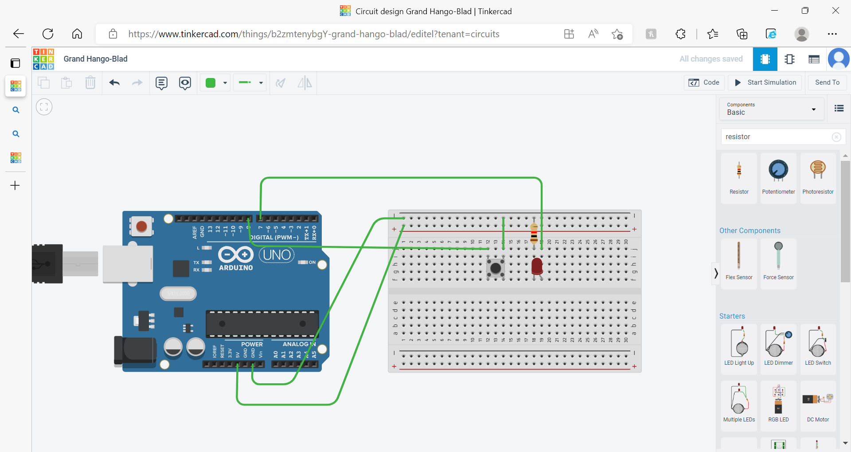

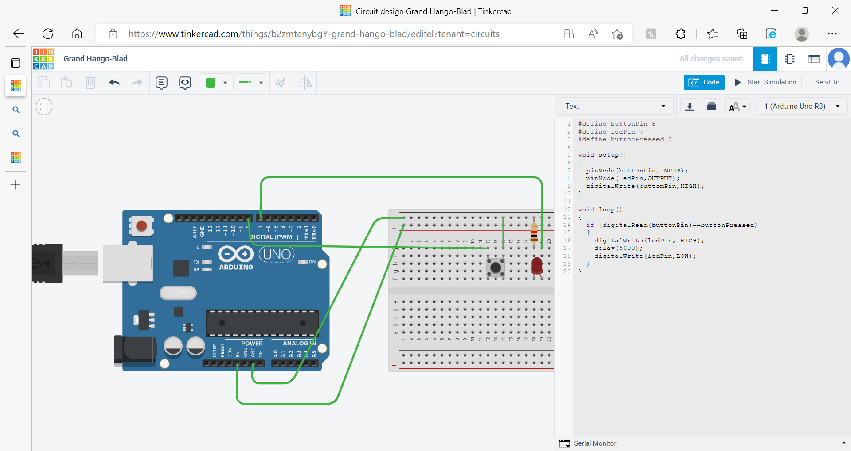

2-)

